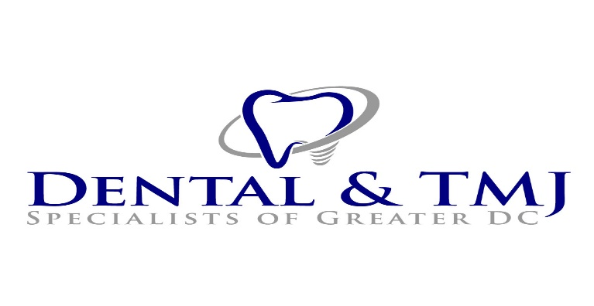

10215 Fernwood Road, Suite 601
Bethesda, MD 20817
Phone (301) 493-9500 / Fax (301) 897-5571

REFERRAL FORM

Date ______________________

Name of Patient __________________________________________________ Phone ______________________

Name of Referring Doctor __________________________________________ Phone ______________________

Prosthodontics Maxillofacial Prosthodontics Endodontics Periodontics Oral Surgery

TMD & Orofacial Pain Obstructive Sleep Apnea Appliance

Michael T. Singer, DDS, FAAMP, FACP, FAAOP John V. Louis
Board Certified Prosthodontist & Maxillofacial Prosthodontist Certified Periodontist
Board Certified in Orofacial Pain Kathleen Frankle Board Certified Endodontist
Sarit Kaplan, DMD, MS, FACP Alan H. Singer
Board Certified Prosthodontist Board Certified Oral & Maxillofacial Surgeon
Lauren Bolding, DDS, MS, FACP
Board Certified Prosthodontist & Maxillofacial Prosthodontist
Carl F. Driscoll, DMD, FACP
Board Certified Prosthodontist & Maxillofacial Prosthodontist

TMJ evaluation Complete dentures
TMJ appliance Dental implants
TMJ caused by Lyme disease Implant reconstruction
Clenching / bruxism / teeth grinding Removable partial dentures
Ear Pain / Tinnitus / Vertigo Crown(s) tooth # _______________
Facial pain – unexplained pain Crown & bridge prosthodontics
Trigeminal neuralgia Cosmetic restorations
Trauma – facial & head pain All-on-4 (Teeth-in-a-Day)
Headaches / migraine headaches Overdentures
Hygiene – specialized for TMJ Pre or post Cancer treatment
Bone grafting Pre-surgical clearance
Tooth extraction Ectodermal Dysplasias (oral cavity)
Oral pathology & biopsy Craniofacial prosthetics secured w/ implants
Possible root canal Invisalign
Wisdom teeth extraction CBCT scanning

Other: ____________________________________________________________________________________________
_______________________________________________________________________________________
_______________________________________________________________________________________

